13th Annual Canine Classic Golf Scramble
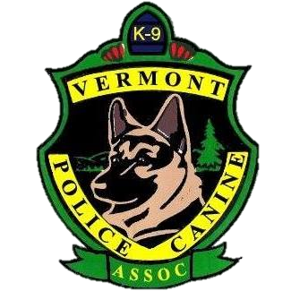

Sugarbush Golf
1091 Golf Course Rd
Warren, Vermont

Friday, August 16th

Cost: $85 per player

100 Golfers - 25 Teams
Registration: 9:00 am

Shotgun t-time: 10:00 am

Cost includes:

- 18 holes of golf
- Golf cart
- BBQ dinner
- Golf Tournament
t-shirt
- Contest prizes for:
- 1st - 3rd place
- Longest Drive
- Closest to the Pin challenge
- Hole in One

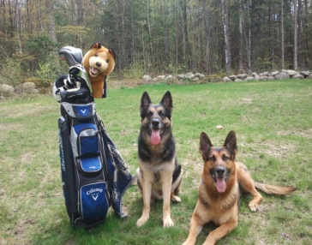

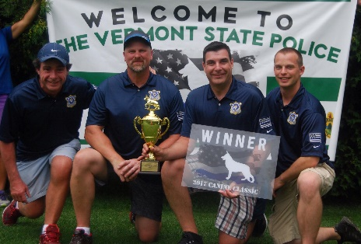
This year our event will be held Friday, August 16th, 2019 at the beautiful Sugarbush Golf Club in Warren, Vermont.

This is a fundraiser for the Vermont Police Canine Association (VPCA). The VPCA is a non-profit organization that is dedicated to providing financial assistance and training to Police Service Dog Teams in Vermont and New Hampshire.

Raffle tickets will be sold the day of the tournament and prizes will be drawn during the dinner.

Your team must be registered with full payment of $340, by August 2nd.

Please make checks payable to the VPCA. This completed form can be dropped off to Robert Ryan at the Vermont Police Academy or can be mailed to:
Robert Ryan
317 Academy Road
Pittsford, VT 05763

For online payments, please email emily.vpca@yahoo.com for instructions.
T-Shirt Size
(men’s sizes)
Player #1
(Team Captain):
Captain’s Email
Player #2:
Player #3:
Player #4:

You can also find a copy of this form on the VPCA website: www.vtk9.com

For more Information on the tournament or for information on sponsoring one of the 18 holes, please contact:

Emily Leinoff: emily.vpca@yahoo.com

